Our house which we will live in the future will have a computer programed into all of the electronics. The computer can control the electricity, all faucets, and door locks inisde of the house.

The computer will have a voice control system where you can communicate with it. The computer will be trained to obey all of the commands you give it and can do anything in the house dealing with technology. The house will have built in alarm throughout the entire household.

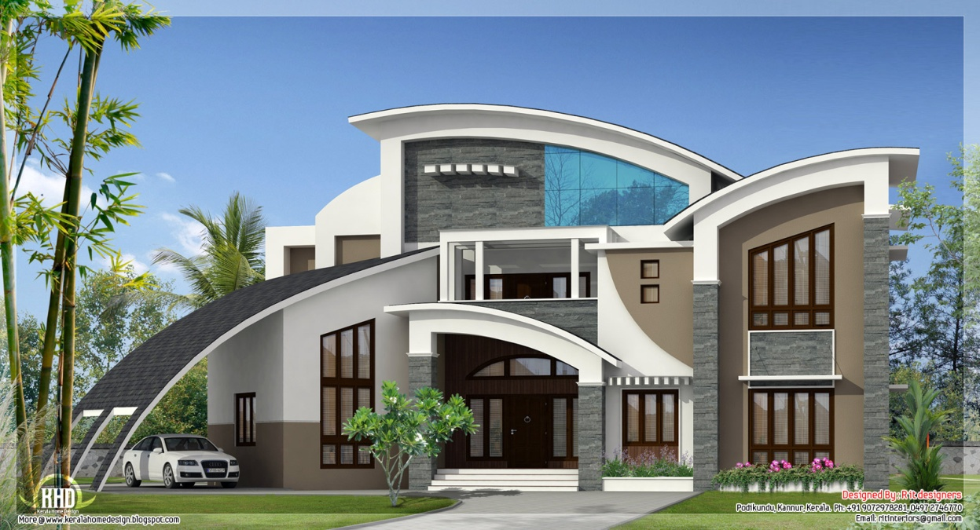

In this future house the floor will be made out of trampolines. There will also be a gameroom, and a built in all sport complex. There will be a home theater with a 180” television with beds that come out of the ground. In this house there will also be a library with an endless amount of books.

***By:Joedy Quintana, Rosendo Gonzales and Andy Gabaldon***